**OUTREACH SCHOOLS EXAMINATION BOARD**

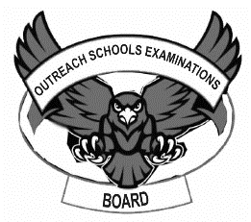 **END OF TERM II EXAMINATION 2024**

**MIDDLE CLASS: (4 – 5 YEARS)**

**LEARNING AREA 3: HEALTH HABITS**

**My name is: …………………………….…………..………………………….**

**My School is: ………………………….………..………….…………………..**

**I am in: ………………………………..…………………………………………………..**

1. 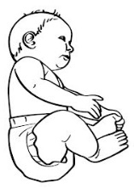**Match the people God has created.**

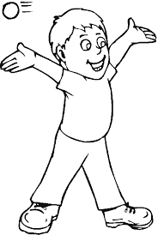

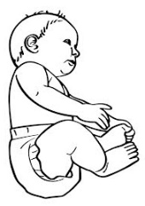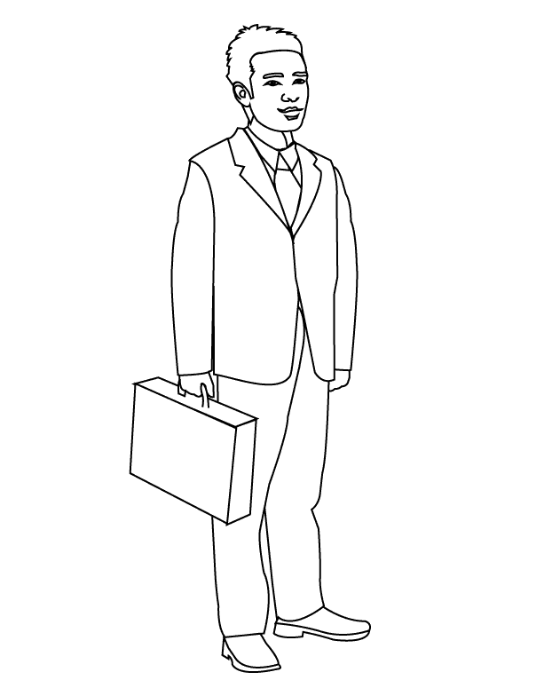

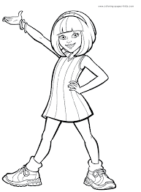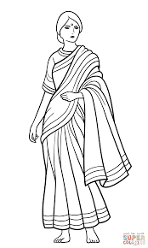





1. **Copy and draw the same things we use to clean our bodies.**

|  |  |
| --- | --- |
| **C:\Users\ABUSHA\Desktop\2018-08-02\003.jpg** |  |
| D:\DESKTOP BACKUP\assesst\SAM PICTURES\SAM PICTURES2\home tools products outline\brush2.jpg |  |
| D:\DESKTOP BACKUP\assesst\SAM PICTURES\SAM PICTURES2\home tools products outline\comb.png |  |
|  |  |
| **C:\Users\ABUSHA\Desktop\2018-08-02\003.jpg** |  |

1. **Name the things that can harm us.**

|  |  |  |
| --- | --- | --- |
|  |  |  |
|  |  |  |
|  |  |  |
|  |  |  |

**pin, pencil, stone, knife, stick, nail**

1. **Copy and write.**

|  |  |  |
| --- | --- | --- |
| leg | eye | nose |
|  |  |  |

1. **Colour these fruits.**

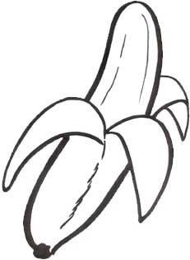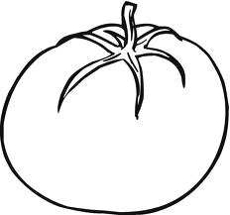

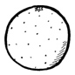

**END**